**Responsible Thinking and Practice**

* Critical Thinking
* System Thinking
* Effective Engagement

By the end of the semester, students will utilize (and develop) the toolkit provided for conducting a responsible practice. The toolkit will be completed and tested in Professional Practice 2.

**Case Study Group Project (50%)**

* Report (20%)
* Group Presentation (10%)
* Toolkit Portfolio (20%)

**Project: Thermal imaging to track coronavirus patients**

Link 1:[Creating safer, smarter spaces - Workplace Safety - Kogniz](https://www.kogniz.com/)

~~Link 2:~~ [~~403 Forbidden (feevr.tech)~~](https://www.feevr.tech/)

10 questions help you to **collect the relevant information** about the project:

* What is the project about?
* What is the context?
* What are the binding guidelines/standards that shape engineers’ judgments and policymakers’ decisions in the project?
* Who are the key actors in the project?
* Who benefits most from the project?
* Who is marginalized in the project, and why?
* Which types of skill set are necessary in completing the project?
* How the project is interacting with social and environmental systems?
* What are the ethical challenges for the engineers involved in the project?
* What are the points of conflicts among different actors involved?

(During the week 8, team will present the initial idea of their toolkits to their tutors. The tutors will provide feedback to each team group as well as an indicative mark for their toolkit portfolio. Students needs to incorporate the feedbacks/comments into their final submission. Failing to do so, up to 50% of the final mark will be deducted. )

**Assessment:**

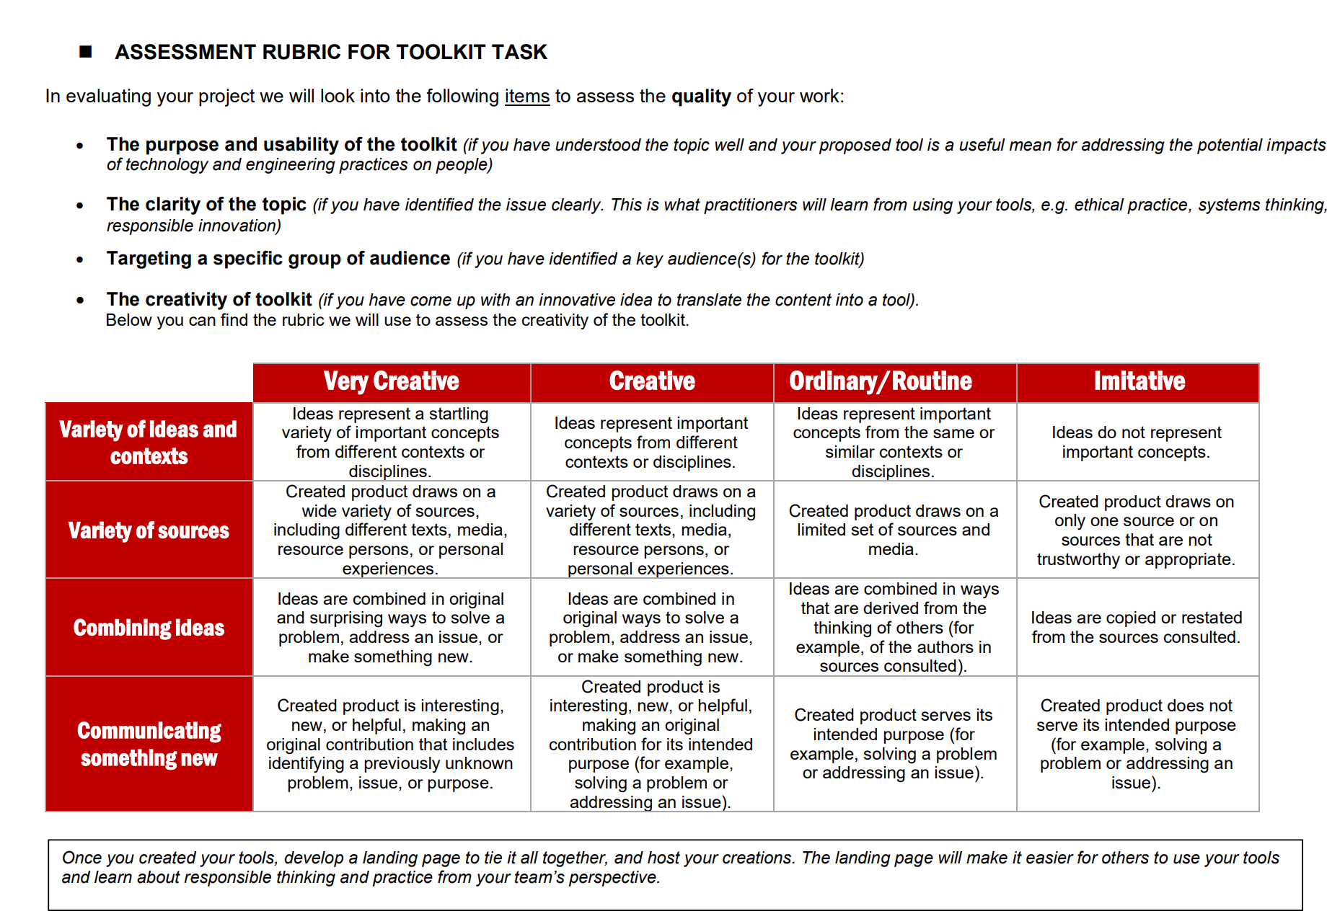

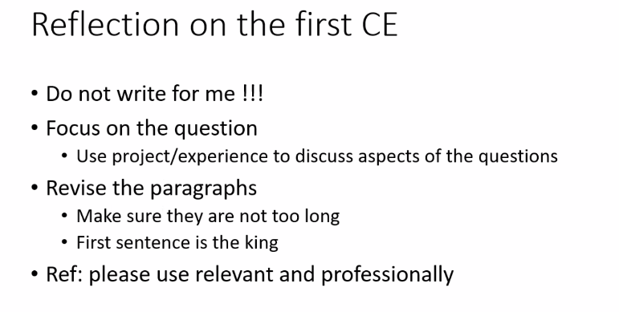

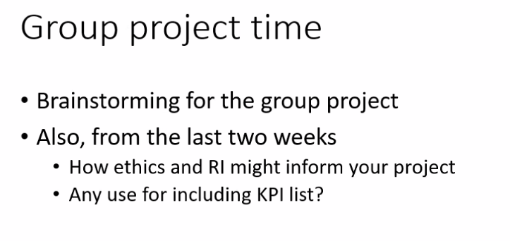

**Resource**

* OxCGRT: <https://github.com/OxCGRT/covid-policy-tracker>
* USA Covid CDC: <https://www.cdc.gov/coronavirus/2019-ncov/index.html>
* Weekly China CDC: https://weekly.chinacdc.cn/news/TrackingtheEpidemic.htm

1 week research, 2-3 weeks report, 1 week presentation

2000 words

Executive summary

Intro

Project Summary (max 1000)

* Project (200)
* Context (200)
* Stakeholders (300)
* Social and environmental systems around the core project/system (300)

Finding (max 600): unique and key findings from the project discussed

Discussion (max 400): recommendations for responsible professional practice based on the report

Conclusion

